Invite. Inspire. Innovate. Issue #13  CISPG LEARNING  Catholic Independent Schools Diocese of Prince George  “All learners thriving in connected Catholic Learning Communities”  Hello everyone!  And welcome back to our final term of the 2020-2021 school year. Hopefully, the warmer weather will bring with it increased opportunities to get outside and learn with our students in natural surroundings. In this issue, please note the many invitations to take part in various events and challenges centred around the outdoors; for example, the “Walking Curriculum Challenge” and free workshops from the Outdoor Learning Store. As per usual, many amazing resources are also available from publishers, BC school districts, and generous curriculum “experts”. I hope you find them useful.  It’s spring-cleaning time at the Pastoral Centre, and I would like to give away some excellent resources. Please see the attached photos with descriptions of items that will be given away to a CISPG teacher for use in his/her classroom:  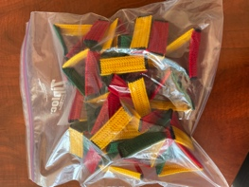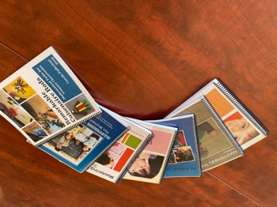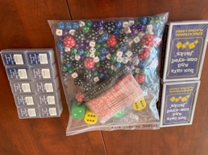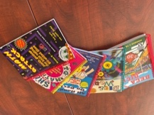  9 sets of “stoplight” triangles Carole Fullerton Math Books Set of Box Car Dice/Cards Accompanying Box Car Books  If you are interested in participating in a draw for these items, please send an email with your name/school and the specific resource that you would like to “win”. I will then draw names and notify the winners in next issue  Enjoy the beautiful weather and Happy Earth Day! Celebrate with these free digital resources from Scholastic Classroom Magazines: https://bit.ly/2OUNOUQ  Frances Roch, Coordinator Curriculum and Instruction  We respectfully acknowledge the unceded ancestral lands of the indigenous nations in which we live, work and play. The Lheidli T’enneh Nation in Prince George. The Tsimshian Nation in Prince Rupert. The Haisla Nation in Kitimat. The Wet’suwe’ten in Smithers. The Treaty 8 First Nations of Alberta in Dawson Creek. |  | 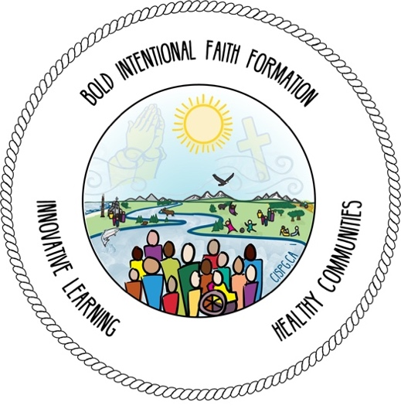  Upcoming Events:  POPEY consultants, Lisa and Jen, are happy to announce the next series of dates for POPEY's After-School Specials, free one-hour online workshops from 3:15-4:15 pm.  To Register, go to this site and check out the flyer: https://www.popey.ca/news/2021/03/aprilmay-after-school-workshops  Wednesday, April 28th:  Reading & Writing Conferences: explore different kinds of conferences, including a range of strategies and coaching conversations to help assess and support students’ literacy development.  Wednesday, May 12th:  Play-Based Literacy Learning: explore how play experiences and literacy centres can be used to guide and shape children’s literacy learning and support early reading and writing development.  Wednesday, May 26th:  Student Self-Assessment of the Core Competencies: explore resources and supports that encourage student reflection and self-assessment in relation to literacy learning and the Core Competencies.  Once you register, you'll receive a confirmation email that will include the Zoom meeting ID and passcode. We will also email you on the Monday before each session, with the Zoom link and the handouts, which will be posted on our Handouts page, a few days prior to each session.  Any questions? Contact us at popey@popey.ca - we hope you can join us!
New Resources
All of the resources mentioned in this newsletter have been collected from school districts and educators across the province. Please be reminded that the links embedded within this document are meant to provide examples of “wise practice” across BC. They are not meant to overwhelm, but rather to support CISPG educators with a repository of rich resources. I am grateful to school districts and educators across BC who so generously share their learning with us.

Literacy | - Shared by Adrienne Gear @AdrienneGear: OLLI #19 – Online Learning Lesson Idea The Six Senses of Spring -https://readingpowergear.wordpress.com/2021/03/28/10166/  - Shared by Caroline Brunet from Scholastic: Our Everyday Book Boxes 3 (K-6) are 50% OFF - https://education.scholastic.ca/productlist/EVERYDAY-BOOK-BOX-3 and Stepping Up (7-9) is 25% OFF - https://education.scholastic.ca/category/STEPPING_UP_WITH_LITERACY_PLACE while quantities last. For ordering information, contact cbrunet @scholastic.ca  - Shared on Twitter: How to use skill progressions to teach #writing responsively. New blog from @JSerravallo via @HeinemannPub –  https://blog.heinemann.com/topic/teaching-writing-in-small-groups  - For more Book Talks from Jennifer Serravallo – https://blog.heinemann.com/book-talk-live-jennifer-serravallo-introduces-teaching-writing-in-small-groups

Numeracy | - Shared by Janice Novakowski @jnovakowski38: New SD38 Math Studio Series video for children, families and teachers: Origami Rabbit https://youtu.be/o_wo5mgA0sw  - Also shared by Janice Novakowski @jnovakowski38: Save the dates! The Indigenous K-12 Math Education Network will be hosting their annual symposium virtually this year on May 11 & 18, cohosted by UBC and UFV. We will be featuring Anishinaabe artist Nico Williams and the math of beading. Registration info coming soon!  - Shared by Mark Nechanicky @MarkNechanick: Here is my collection of number talk resources. What am I missing? What do you use with Ss? https://docs.google.com/presentation/d/1HHG4fcRFOWXuKN5ni9K7W9SUW0m2WDM7RkTPd4UD_RY/edit#slide=id.gcc4ed230bc_0_273

Explorations | 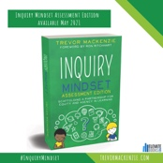  - Shared by Trevor Mackenzie @trev_mackenzie: Here it is! #InquiryMindset Assessment Edition is coming in May!  - Shared by the Networks of Inquiry and Indigenous Education (NOIIE): Check out the @noiie_bc resources: https://noiie.ca/resources/ A framework for conceptualizing and developing your inquiry-based approach. These are also helpful as points of discussion and reference during staff meetings and colleague collaboration.  - Shared by Brooke Moore @bmooreintheloop: Check this out! Teachers who want to teach students to make good values-based decisions can download the FREE Decision Maker Playbook. Easy to photocopy pages to use with your kids. Also, classroom ready tools. https://deltalearns.ca/decisions/  - Shared by the Critical Thinking Consortium TC2 @TC2thinks: New Resources!  We've added two NEW card sets to our Snapshots in Time/Clichés d'histoire collection! These visual timeline cards highlight significant events in Canadian history from pre-history to present day. Order now & SAVE 25% off! http://tc2.ca/cdh-sit

PHE/SEL | - Shared by CASEL @caselorg: 10 indicators of schoolwide SEL - https://bit.ly/32geZOe  - Also shared by CASEL @caselorg: The #SEL 3 signature practices can help you integrate SEL practices into any classroom or meeting to promote community-building and deeper engagement. Download the playbook for free guidance & tools: https://bit.ly/3gr4Cvc. You will need to create a free account  - Shared by BC Ministry of Education in Learn magazine: Looking for resources connected to the K-7 Physical and Health Education curriculum? Check out the School Physical Activity and Physical Literacy project: https://schoolpapl.ca/  This free school-based health promotion initiative is intended to help educators build capacity and increase their confidence in delivering quality physical activity and physical literacy opportunities. The website provides a variety of resources and professional development components such as self-paced e-learning courses, virtual workshops and webinars. You can also access a database of games, activities and lesson plans to support movement in your physical education class and throughout the school day.  - Shared by Megan Venezia @venezia_megan: New SEL resource that supports the Dictionary of Emotions!! This resource gives Ss an opportunity to talk about strategies to use to self-regulate and includes journal prompts for each of the emotions https://docs.google.com/presentation/d/1mnDpTQalUB-xb06hAsraR5i7ZgjzRtjjum7l8U2I0pU/edit#slide=id.gccc9aa2c1c_0_45  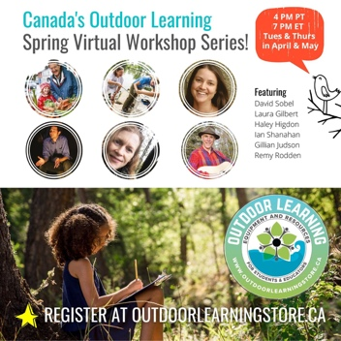  - The Outdoor Learning Store is now officially offering learning resources and equipment to educators across Canada. More details at: http://outdoorlearningstore.ca  - Also shared by Outdoor Learning Store – FREE WORKSHOPS - from the top names in Enviro Ed Register at http://outdoorlearningstore.ca/workshops  - Check out these great educational supports for 'learning through focused walking' from Education That Inspires! http://educationthatinspires.ca/2016/01/25/a-w  - Shared by Rose Pillay @RosePillay1: pre-K-12 educators sign up now for 30 Days of Outdoor Learning: Starts May 3, 2021  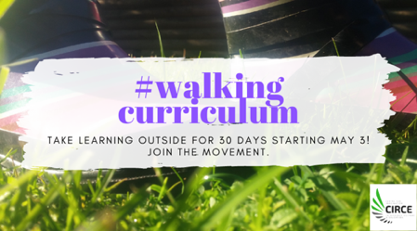  - http://circesfu.ca/practice/ecological-place-based-education/the-walking-curriculum-challenge-spring-2021/  - Also shared by Rose Pillay: 50 Educational Brain Breaks https://weareteachers.com/brain-breaks-for-kids/#.YHdmdx_aPYA.twitter via @WeAreTeachers

Indigenous Ed  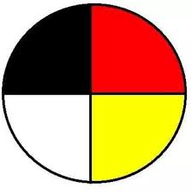 | - Shared by Canadian Geographic Education @CanGeoEdu: Have you seen the Michif Language and Métis Culture lesson plans available on our Online Classroom? Developed in partnership with @metisnationsask, they explore the topics of beading, jigging, traditional foods and more. https://onlineclassroom.cangeoeducation.ca  - Check out @NadineMcSpadden’s excellent compilation of resources that support indigenous ways of learning with, from & on the land with our students: “So many questions about outdoor learning and connections to Indigenous ways of knowing and being.” This is a work in progress. https://aboriginalresourcesforteachers.weebly.com/outdoor-learning.html

Inclusive Ed | - The remaining Inclusive & Competency Based IEP Learning Sessions 7, 8, and 9 are open for registration with an incredible line up including Katie White! https://eventbrite.ca/o/shelley-moore-30308766560  - Also shared by Shelley Moore: In this third video of "The Five 'P's' of Inclusion" Series, this video looks at the critical role of PEERS to our understanding of inclusion. In this video we advocate to move away from one-to-on adult support and towards meaningful and balancing peer connection and mutual learning. https://www.youtube.com/watch?v=0uZRZXTrAhA

Assessment | - Shared by Rea Smith @realawsmith: Please check out the http://allthingsassessment.info website for great support materials and books written by the ATA Center’s authors.  - Shared by Alberta Assessment: Spring Assessment Series  Join us for interactive and engaging online learning. For session descriptions: https://aac.ab.ca/events-and-workshops/aac-open-sessions/

Professional  Learning | - Engaging All Learners in The Middle Years:  Webinar #4 – Wednesday, April 21st – Self-Regulated & Social Emotional Learning with Leyton Schnellert and Miriam Miller. To register and view Archived Webinars #1, #2, and #3 check out this link: https://learn.sd61.bc.ca/news-events/webinars/ with thanks to SD #61 Greater Victoria School District.  - The Educational Spring Fling K-12 Conference is taking place virtually on April 23rd! Join educators and community members from North Central BC and beyond for a rich day of learning and connection. Please visit: http://edfling.ca. Shared by Glen Thielmann @glenthielmann on Twitter: "A Youth Panel on #ClimateChange Education in BC Schools" is a free workshop from 10-11AM for anyone in #bced. https://edfling.ourconference.ca/index.php?Page=Workshop&code=WVLSAFS. Use the invitation code CLIMATE to bypass payment when registering.  - Shared by NOIIE – Networks of Inquiry and Indigenous Education Are you ready to turn up the volume on the areas of practice that make a real difference for learners? Join the conversation at the #noiie symposium May 12-13. Register here: https://noiie.ca/2021-noiie-sym  - On Friday, May 21, 2021 the Provincial Intermediate Teachers’ Association (myPITA) and the BC Association of Teachers of Modern Languages (BCATML) proudly presents an Online Spring Conference. Register at http://mypita-spring.ourconference.ca. The early bird rate is available until April 21, 2021.

